Deleting and Replacing Cal Groups Bug

# Intent

For testing purposes, I need to be able to programmatically upload, use and delete cal groups. Specifically, I am writing unit tests for the calibration dialog. This dialog should be able to handle a mixture of both channel calibrations and cal groups. I want to test the dialog in various situations: When no channel corrections are present, when no cal groups are present, when both channel calibrations and cal groups are present, etc.

My unit tests that use said functionality work on the ZNB, but cause the ZVA firmware to lock up and eventually crash.

# Problem

The MMEMory:DELete:CORRection command is not working properly. This command should delete a cal group from the firmware, including the physical fie containing the correction data. I can confirm that the cal group file is deleted. However, the cal group continues to be shown in the firmware as an available cal group. Also, copying the cal group back to the firmware then trying to apply it to a channel causes the firmware to crash.

# Scope

Confirmed on:  
- ZVA firmware 3.60

# Work-around

The cal groups are stored in the C:\Rohde&Schwarz\Nwa\Calibration\Data folder as files with a .cal extension. Using this information and the more general MMEMory:DELete command one can delete the cal files directly. This approach avoids crashing the firmware and is sufficient for programmatic purposes. It does not, however, get the firmware to display the correct list of cal groups to a manual user. So beware of this shortcoming.

# Example

**In this example I will start with the firmware closed in order to provide it with a cal file that I will then delete and replace.**

**Initial Trace***X-Axis: -20 dBm to 0 dBm*

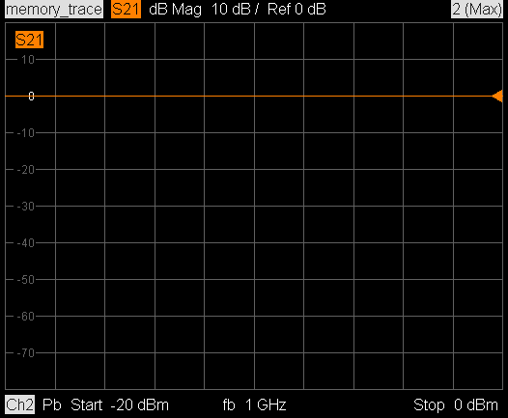

**Truncated trace***X-axis: -30 dBm to 10 dBm*

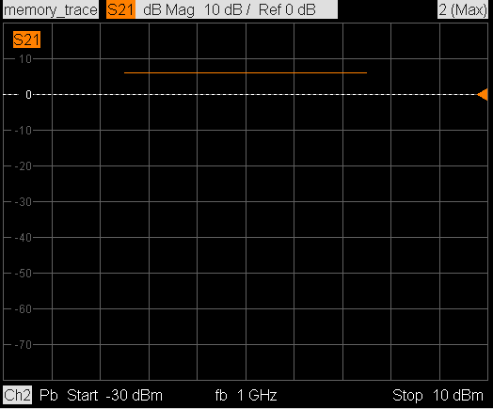

**# With the firmware closed, copy the cal group file  
# (“Cal Group 1.cal”) to the following folder on the ZVA:  
# C:\Rohde&Schwarz\Nwa\Calibration\Data**

**# Open the firmware**

**# Preset the instrument:  
*RST**

**# Confirm that cal group “Cal Group 1” is present:  
# Cal (hard key) -> Cal Manager (soft key)**

**# Delete the cal group programmatically  
# NOTE: LOWER CASE!!! Because it’s what the firmware  
# returns when you “ls” or “dir”  
MMEM:DEL:CORR ‘cal group 1.cal’**

**# Navigate back to the Cal Manager  
# [Cal (hard key) -> Cal Manager (soft key)]  
# and confirm that the cal group is still present in the menu.  
# Also, navigate to  
# C:\Rohde&Schwarz\Nwa\Calibration\Data  
# and confirm that the cal group has indeed been removed.  
# Listing a removed cal group in the Cal Manager menu is a bug.**

**# To make the firmware crash:**

**# Manually copy the cal group back to the ZVA:  
# Folder: C:\Rohde&Schwarz\Nwa\Calibration\Data  
# This can of course be done programmatically, but not in  
# GPIB Explorer**

**# Load the cal group into channel 1  
MMEM:LOAD:CORR 1, ’Cal Group 1.cal’**

**Note: At this point you should observe a SCPI command error from the ZVA stating that “**